Software installation requirements
Please attempt installing the software at least 14 days prior to the start of the winterschool.
If you encounter problems installing one or the other software, please continue with the instructions for the next program. If you did not succeed in intalling one or more of the programs, please send an email to k.doblhoff-dier@lic.leidenuniv.nl with the topic “Han-sur-Lesse: software installation” describing your problems.

IQmol
IQmol is a graphical interface to QChem, a quantum chemistry software package focused on molecular systems. IQmol will allow you to do simple QChem calculations on a server without the need for a QChem license or the need to install QChem.
Instructions
- Download (and compile if necessary for your system (i.e. Linux)) IQmol from here: IQmol Download
- Try to run the program. You should see a window looking like this: 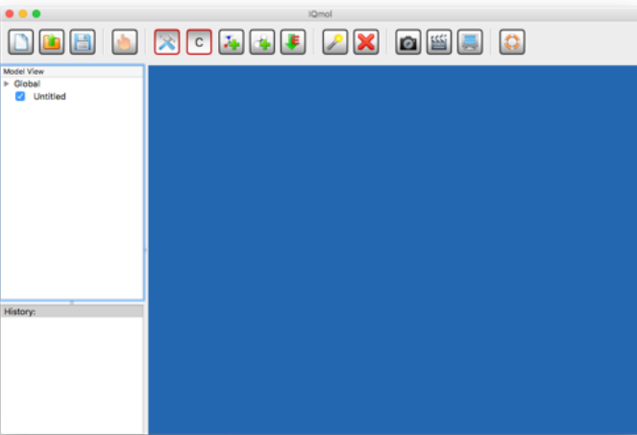
If this works, you should be all set for IQmol and you can continue with the next code.

Gpaw
Gpaw is a versatile, python-based density functional theory code.
Instructions on Windows
- Install and set up Windows subsystem for Linux as described here: Install WSL | Microsoft Learn. (Note that I had to run the command wsl --install twice for whatever reason until it actually installed a distro). The default Linux distro that is installed should be Ubuntu. Please keep that.
- You will need to restart your computer (Note: I actually needed to restart twice – once after every call to wsl--install. No idea why.)
- Open Ubuntu either from the start menu or via the terminal.
- Follow the instructions given here WSL Ubuntu 20.04+ — GPAW for the conda installation (Not the classical installation!)
- Try to run “gpaw --info". If you get something looking like this, you should be fine:
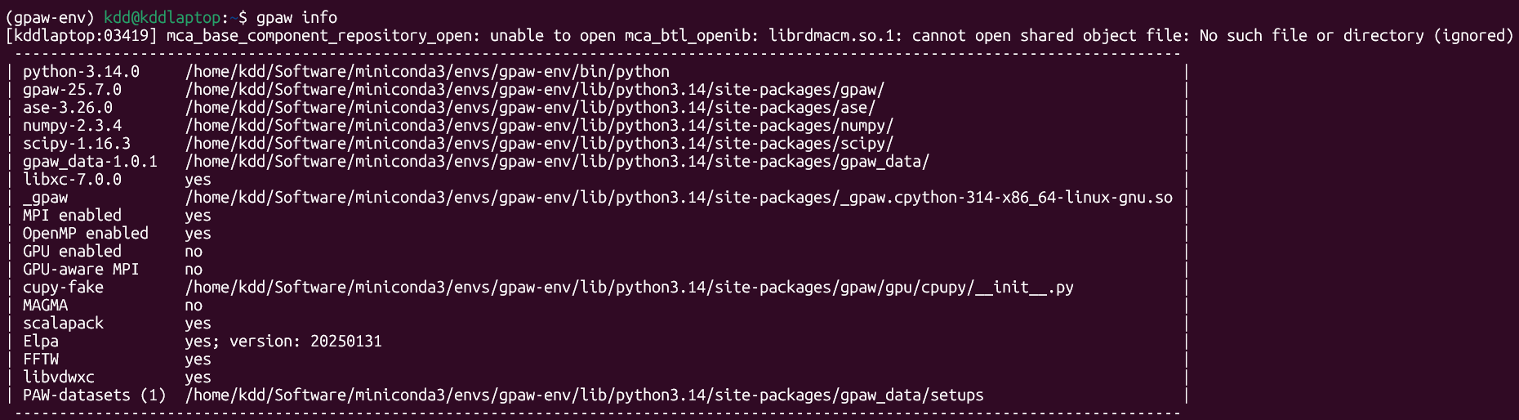

Instructions on Mac
- Follow the instructions here: Homebrew — GPAW.
- Note: You may want to use a venv in python to encapsulate gpaw. However, I do not have a Mac, so I could not test this. If you do not know what a venv is, then you probably also do not need it.
Instructions on Linux
- If your linux distribution does not have python 3 preinstalled, install python (note!: I did not test this!)
  - sudo apt update
  - sudo apt upgrade
  - sudo apt install python3
- Follow the instructions here: Installation — GPAW to install gpaw
- Note: You may want to use a venv in python to encapsulate gpaw. However, I do not have a Mac, so I could not test this. If you do not know what a venv is, then you probably also do not need it.

